**Customer Table**

* **Create Query:**

**Create table “CUSTOMER” with attributes CUSTOMER_ID, CNAME for customer name, NIC_NO (PK), BOOKING_DATE for hall booking, HNAME for booked hall by customer and CONTACT_NO for customer’s phone number.**

CREATE TABLE CUSTOMER

(CUSTOMER_ID NUMBER(4) ,

CNAME VARCHAR2(20),

NIC_NO VARCHAR2(16) PRIMARY KEY,

BOOKING_DATE DATE,

HNAME VARCHAR2 (30),

CONTACT_NO VARCHAR(15));

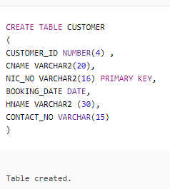

* **Insert Queries:**

INSERT INTO CUSTOMER VALUES(1001,'JAMIL SHAH','35202-4567890-3',

TO_DATE('19-JAN-2018','DD-MON-YYYY'),'DEWAN-E-KHAAS','+92-42-34307052');

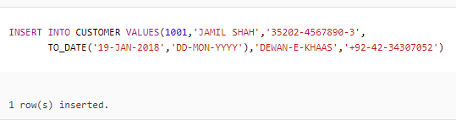

INSERT INTO CUSTOMER VALUES(1002,'ADIL HUSSAIN','35202-5668607-2',

TO_DATE('21-JAN-2018','DD-MON-YYYY'),'AL-JANNAT','+92-42-36532450');

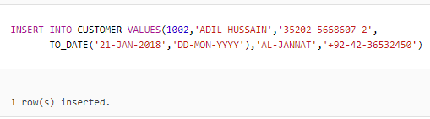

INSERT INTO CUSTOMER VALUES(1003,'SAEED MUKHTAR','35202-3567897-3',

TO_DATE('22-JAN-2018','DD-MON-YYYY'),'AL-JANNAT','+92-42-35678901');

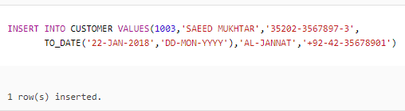

INSERT INTO CUSTOMER VALUES(1004,'MAJID SAEED','35202-2557981-4',

TO_DATE('19-JAN-2018','DD-MON-YYYY'),'TAJ MAHAL','+92-42-31245677');

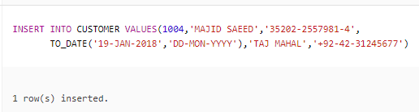

INSERT INTO CUSTOMER VALUES(1005,'ALI SHAH','35202-2657971-5',

TO_DATE('18-JAN-2018','DD-MON-YYYY'),'LAHORE CASTLE','+92-42-31285697');

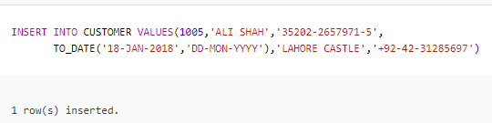

INSERT INTO CUSTOMER VALUES(1006,'RAHEEL HUSSAIN','35202-25000981-9',

TO_DATE('23-JAN-2018','DD-MON-YYYY'),'MUGHAL-E-AZAM','+92-42-31240057');

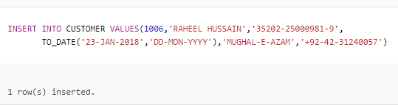

INSERT INTO CUSTOMER VALUES(1007,'ADIL HAMEED','35202-4007981-4',

TO_DATE('18-JAN-2018','DD-MON-YYYY'),'MUGHAL-E-AZAM','+92-42-31246660');

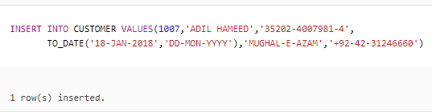

* **Delete Queries:**



**Remove the record of a customer having CUSTOMER_ID 1008.**

DELETE FROM CUSTOMER

WHERE CUSTOMER_NO = 1008;

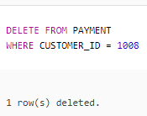



**Remove the record of a customer having CUSTOMER_ID 1009.**

DELETE FROM CUSTOMER

WHERE CUSTOMER_NO = 1009;

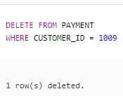



**Remove the record of a customer having CUSTOMER_ID 1010.**

DELETE FROM CUSTOMER

WHERE CUSTOMER_NO = 1010;

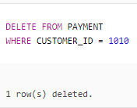



**Remove the record of a customer having CUSTOMER_ID 1011.**

DELETE FROM CUSTOMER

WHERE CUSTOMER_NO = 1011;

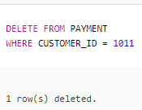



**Remove the record of a customer having CUSTOMER_ID 1012.**

DELETE FROM CUSTOMER

WHERE CUSTOMER_NO = 1012;

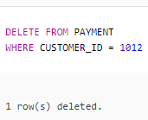

* **Update Queries:**

1. **A customer having CUSTOMER_ID 1001 changed the booked hall. Now he booked QASAR-E-NOOR.**

UPDATE CUSTOMER

SET HNAME = 'QASAR-E-NOOR'

WHERE CUSTOMER_ID = 1001;

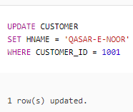



**A customer having CUSTOMER_ID 1004 changed his hall booking date from 19-JAN-2018 to 29-JAN-2018.**

UPDATE CUSTOMER

SET BOOKING_DATE = '29-JAN-2018'

WHERE CUSTOMER_ID = 1004;

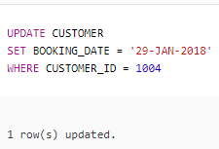



**Update the data of customer having CUSTOMER_ID 1007. He booked AL-JANNAT hall for 19-JAN-2018 and his contact number is +92-42-31246666.**

UPDATE CUSTOMER

SET HNAME = 'AL-JANNAT', BOOKING_DATE = '19-JAN-2018’, CONTACT_NO = '+92-42-31246666'

WHERE CUSTOMER_ID = 1007;

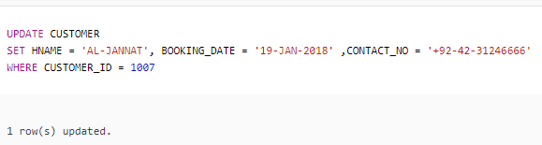



**Change the CUSTOMER_ID from 1007 to 1009.**

UPDATE CUSTOMER

SET CUSTOMER_ID = 1009

WHERE CUSTOMER_ID = 1007;

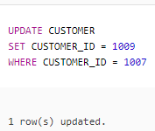



**Update the contact number of customer +92-42-36532400 where CUSTOMER_ID is 1002.**

UPDATE CUSTOMER

SET CONTACT_NO = '+92-42-36532400'

WHERE CUSTOMER_ID = 1002;

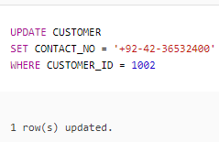

* **Other Queries:**

1. **Show hall names and customers as “ QASAR-E-NOOR HAS BEEN BOOKED BY JAMIL SHAH ”**

SELECT HNAME || ‘ IS BOOKED BY ‘ || CNAME “HALL BOOKED BY CUSTOMER”

FROM CUSTOMER;

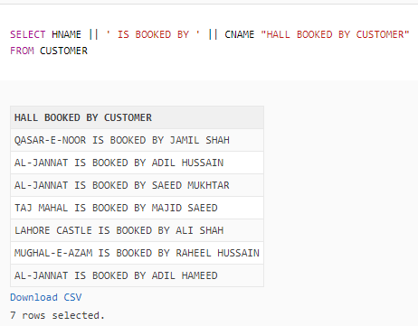

1. **Give names of those customers who have ‘A’ in their names.**

SELECT CNAME

FROM CUSTOMER

WHERE CNAME LIKE ‘%A%’;

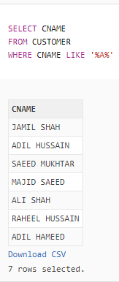

1. **Give names of those customers who have id number greater than 1006.**

SELECT CNAME

FROM CUSTOMER

WHERE CUSTOMER_ID > 1006;

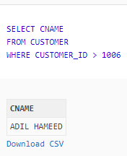

1. **Show hall names and nic number of customer having customer number 1001, 1007 and 1006 or having ‘i’ in their names.**

SELECT HNAME, NIC_NO

FROM CUSTOMER

WHERE CUSTOMER_ID IN (1001, 1006, 1007)

OR CNAME LIKE ‘%I%’;

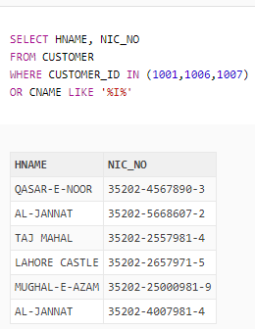

1. **Show customer names as “CUSTOMER NAME” and nic number as “NIC”.**

SELECT CNAME “CUSTOMER NAME” , NIC_NO “NIC”

FROM CUSTOMER;

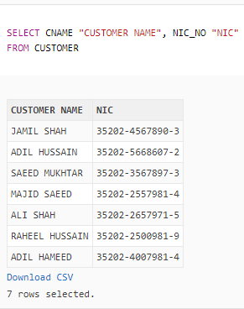

1. **Show customer names and customer id in descending order.**

SELECT CUSTOMER_ID, CNAME

FROM CUSTOMER

ORDER BY CUSTOMER_ID DESC;

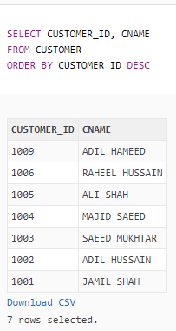

1. **Show all the customers and their advance amount whose advance is greater than 70000.**

SELECT C.CNAME, ADVANCE

FROM CUSTOMER C, PAYMENT P

WHERE C.CUSTOMER_ID = P.CUSTOMER_ID

AND ADVANCE > 70000;

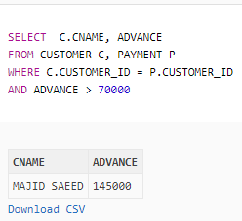

1. **Give names and customer id of those customers whose one third advance payment is greater than 9000.**

SELECT C.CUSTOMER_ID, C.CNAME

FROM CUSTOMER C, PAYMENT P

WHERE C.CUSTOMER_ID = P.CUSTOMER_ID

AND (ADVANCE/3) > 9000;

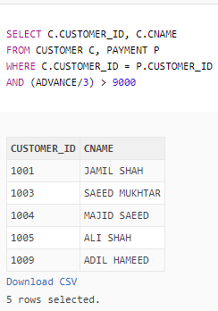

1. **Give customer names as “Customer Names”, booking date as “Booked Date”, add 8 months in every date as “8 Months Added”.**

SELECT CNAME “CUSTOMER NAME”, BOOKING_DATE “BOOKED DATE” ADD_MONTHS (BOOKED_DATE, 8) “8 MONTHS ADDED”

FROM EMPLOYEE;

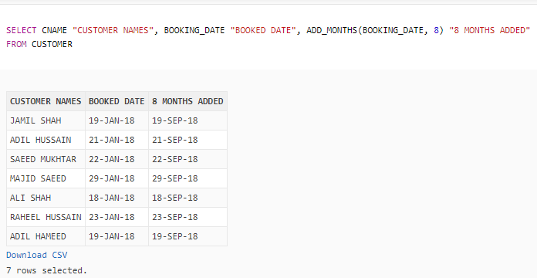

1. **Give booking date of those clients who have been booked DEWAN-E-KHAAS.**

SELECT BOOKING_DATE

FROM CUSTOMER

WHERE HNAME = ‘DEWAN-E-KHAAS’;

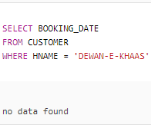

1. **Give customer name, CNIC as “IDENTIFICATION NUMBER”, whose booking date is ’19 jan-2017’ and id greater than 1002.**

SELECT CNAME, NIC_NO “IDENTIFICATION NUMBER”

FROM CUSTOMER

WHERE BOOKING_DATE = ’19-JAN-2018’

AND CUSTOMER_ID > 1002;

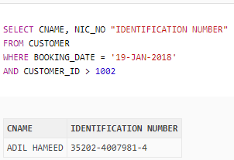

1. **Show id and booking date of all those customers whose hall name is AL-JANNAT or TAJ MAHAL.**SELECT CUSTOMER_ID, BOOKING_DATE

FROM CUSTOMER

WHERE HNAME IN (‘AL-JANNAT’, ‘TAJ MAHAL’);

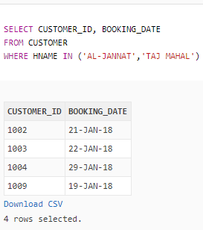

1. **Show complete records of customers who have booked AL-JANNAT.**

SELECT *

FROM CUSTOMER

WHERE HNAME = ‘AL-JANNAT’;

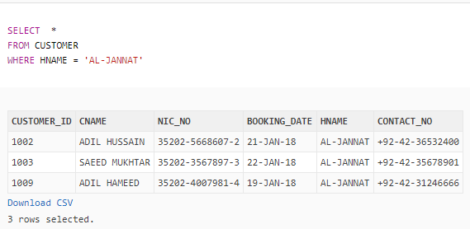

1. **Show booking date of those halls whose has double A in their names.**

SELECT BOOKING_DATE

FROM CUSTOMER

WHERE HNAME LIKE ‘%A%A%’;

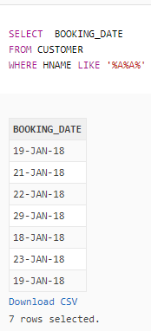

1. **Give customer name, hall name, booking date and nic number of all those customers who have customer id 1009.**

SELECT CNAME, HNAME, BOOKING_DATE, NIC_NO

FROM CUSTOMER

WHERE CUSTOMER_ID = 1009;

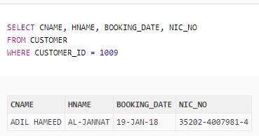

* **Function Queries:**

1. **Give Maximum as “MAXIMUM ADVANCE”, Minimum as “MINIMUM ADVANCE”, Sum as “SUM OF ADVANCE” of advance payments of all those customers who have A and N in their hall names.**

SELECT MAX (ADVANCE) “MAXIMUM ADVANCE” , MIN(ADVANCE) “MINIMUM ADVANCE” , SUM (ADVANCE) “SUM OF ADVANCE”

FROM CUSTOMER C, PAYMENT P

WHERE C.CUSTOMER_ID = P.CUSTOMER_ID

AND HNAME LIKE ‘%A%N%’;

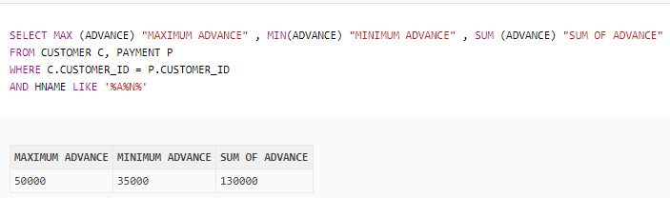

1. **Count customer names as “COUNTS” of customer table.**

SELECT COUNT (CNAME) “COUNT”

FROM CUSTOMER;

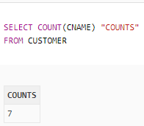

1. **Show hall names as “HALL NAME” and customer names as “CUSTOMER NAME” in lower case.**

SELECT LOWER (HNAME) “HALL NAME”, LOWER (CNAME) “CUSTOMER NAME”

FROM CUSTOMER;

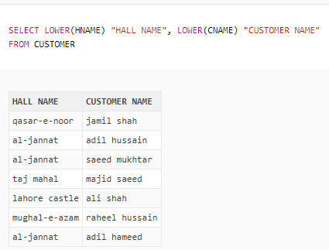

* **Sub-Queries:**

1. **Give customer id, name and contact number of all those customers whose assigned hall name is QASAR-E-NOOR and booking date is equal to those customers who have id 1009.**

SELECT CUSTOMER_ID, CNAME, CONTACT_NO

FROM CUSTOMER

WHERE BOOKING_DATE = ALL (SELECT BOOKING_DATE

FROM CUSTOMER

WHERE CUSTOMER_ID = 1009)

AND HNAME = ‘QASAR-E-NOOR’;

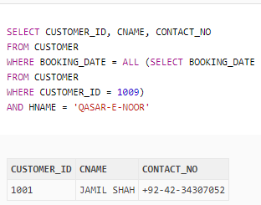

1. **Display name, nic number and advance of those customer whose advance is greater than the advance of those customers whose id 1003.**

SELECT C.CNAME, NIC_NO, ADVANCE

FROM CUSTOMER C, PAYMENT P

WHERE C.CUSTOMER_ID = P.CUSTOMER_ID

AND ADVANCE > (SELECT ADVANCE

FROM PAYMENT

WHERE CUSTOMER_ID = 1003);

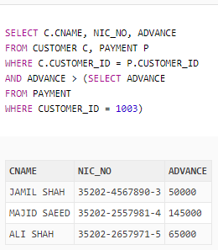

1. **Give all record of those customers whose id is not equal the id of ALI SHAH.**

SELECT *

FROM CUSTOMER

WHERE CUSTOMER_ID <> (SELECT CUSTOMER_ID

FROM CUSTOMER

WHERE CNAME = ‘ALI SHAH’);

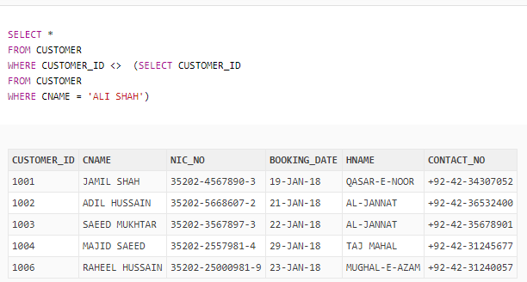

**Table**